|  |  |  |  |  |  |  |  |
| --- | --- | --- | --- | --- | --- | --- | --- |
| Capstone Project Step-by-Step Solution | | | | | |  | Task |
| 1 |
|  | | | | |  |  |  |
|  |  |  |  |  | | |
|  | | | | |  |  |

Modify the Incident form so that it supports a new process for troubleshooting technical issues reported by Strawberry sFone users.

**Refer to** Module 3: Configure Applications for Business

1. Create a New Form Field

Create a new field and add it to the Default view of the Incident form.

1. Navigate to **All > Incident > Create New**.
2. Click the **Additional Options Menu**, then select **Configure > Form Layout**.

Ensure Default view is selected in the View name choice field under the Form view and section.

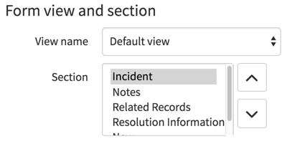

1. Under the **Create new field** section, populate the properties as follows:

Name: **sFone Model**Type: **String**  
Field length: **Small (40)**

1. Click **Add**.

1. Move the **sFone Model** field up under **Configuration item** in the **Selected** column.

1. Click **Save**.
2. Click to **Close** the Saving Form Section message.

1. Add a Choice Field Option

Add a new choice value to the Category field.

1. From the Incident record, right-click on the **Category field label**.
2. Select **Configure Choices**.

1. Type **sFone**into the **Enter new item** field.

1. Click **Add**.
2. Click **Save** to return to the incident record. Confirm the **sFone** choice appears last on the list for the **Category** field.

1. Create a Non-P1 sFone Incident

Create a Non-P1 sFone Incident to put your form changes into action.

1. Navigate to **All > Incident > Create New**.
2. Populate the form with the following properties:
   * Caller: Megan Burke
   * Category: sFone
   * Short Description: **My sFone will not turn on.**
3. Click **Submit**.

TASK VERIFICATION

Verify that the new sFone category choice and sFone Model field appear on the Default View of the Incident form.

*******